Тhe structure of the “Catalog of the magnetic variations at the Panagjurishte station” is presented in the figure below. During its development, the catalog structure went through several modifications [2, 3]*. In the present variant, the catalog consists of three basic sections: Magnetic field data, Data about MPB, and Catalog publications.
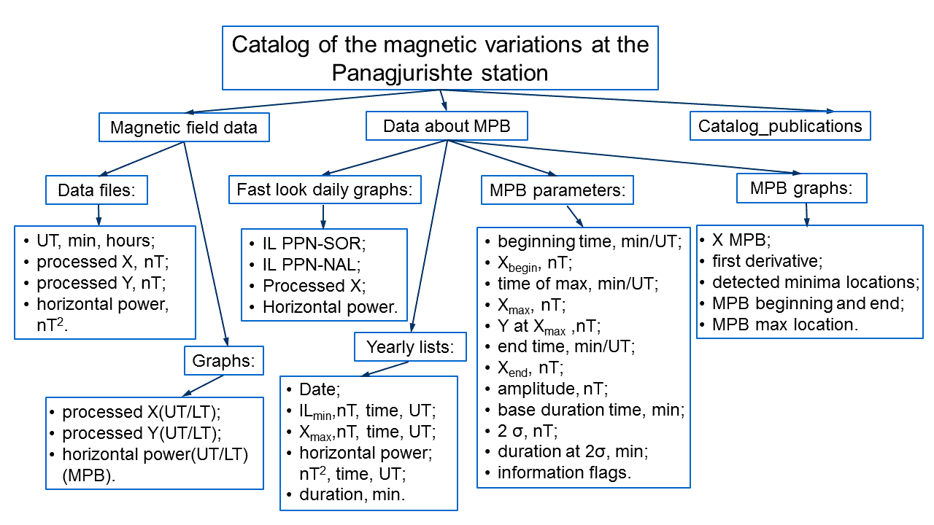
In the section Magnetic field data, the processed X and Y magnetic components and the computed horizontal power of the magnetic field at PAG (subsection Data files), as well as their graphics (subsection Graphs), from 2007 to 2022, are stored. The processing procedure, based on the algorithm by McPherron and Chu [2017] with some new developments is described in [1, 2, 4]. The second section, Data about MPB, consists of four subsections: Fast look daily graphs, Yearly lists, MPB parameters and MPB graphs. Fast look daily graphs comprises combined graphics, including the IL index, computed for the IMAGE PPN-SOR and PPN-NAL magnetometer station chains, the X-component variations and the horizontal power of the magnetic field. The Yearly lists include data about the cases in which noticeable variations (midlatitude positive bays - MPB) are observed at the time of the substorms, verified by the IL index. In the sections Fast look daily graphs and Yearly lists are uploaded data and graphs from 2007 to 2022. The subsections MPB parameters and MPB graphs contain data files with the midlatitude positive bays parameters and graphics, visualizing every detected positive bay. Section Catalog publications grants access to the papers, describing the catalog or using data from it for some study.
The catalog contains information for the period 2007-2022 and will be updated every year. In each sub-folder with numerical or graphic data, a readme file is positioned, in which information about the details of the character and the presentation of the data in the respective sub-folder is given.

